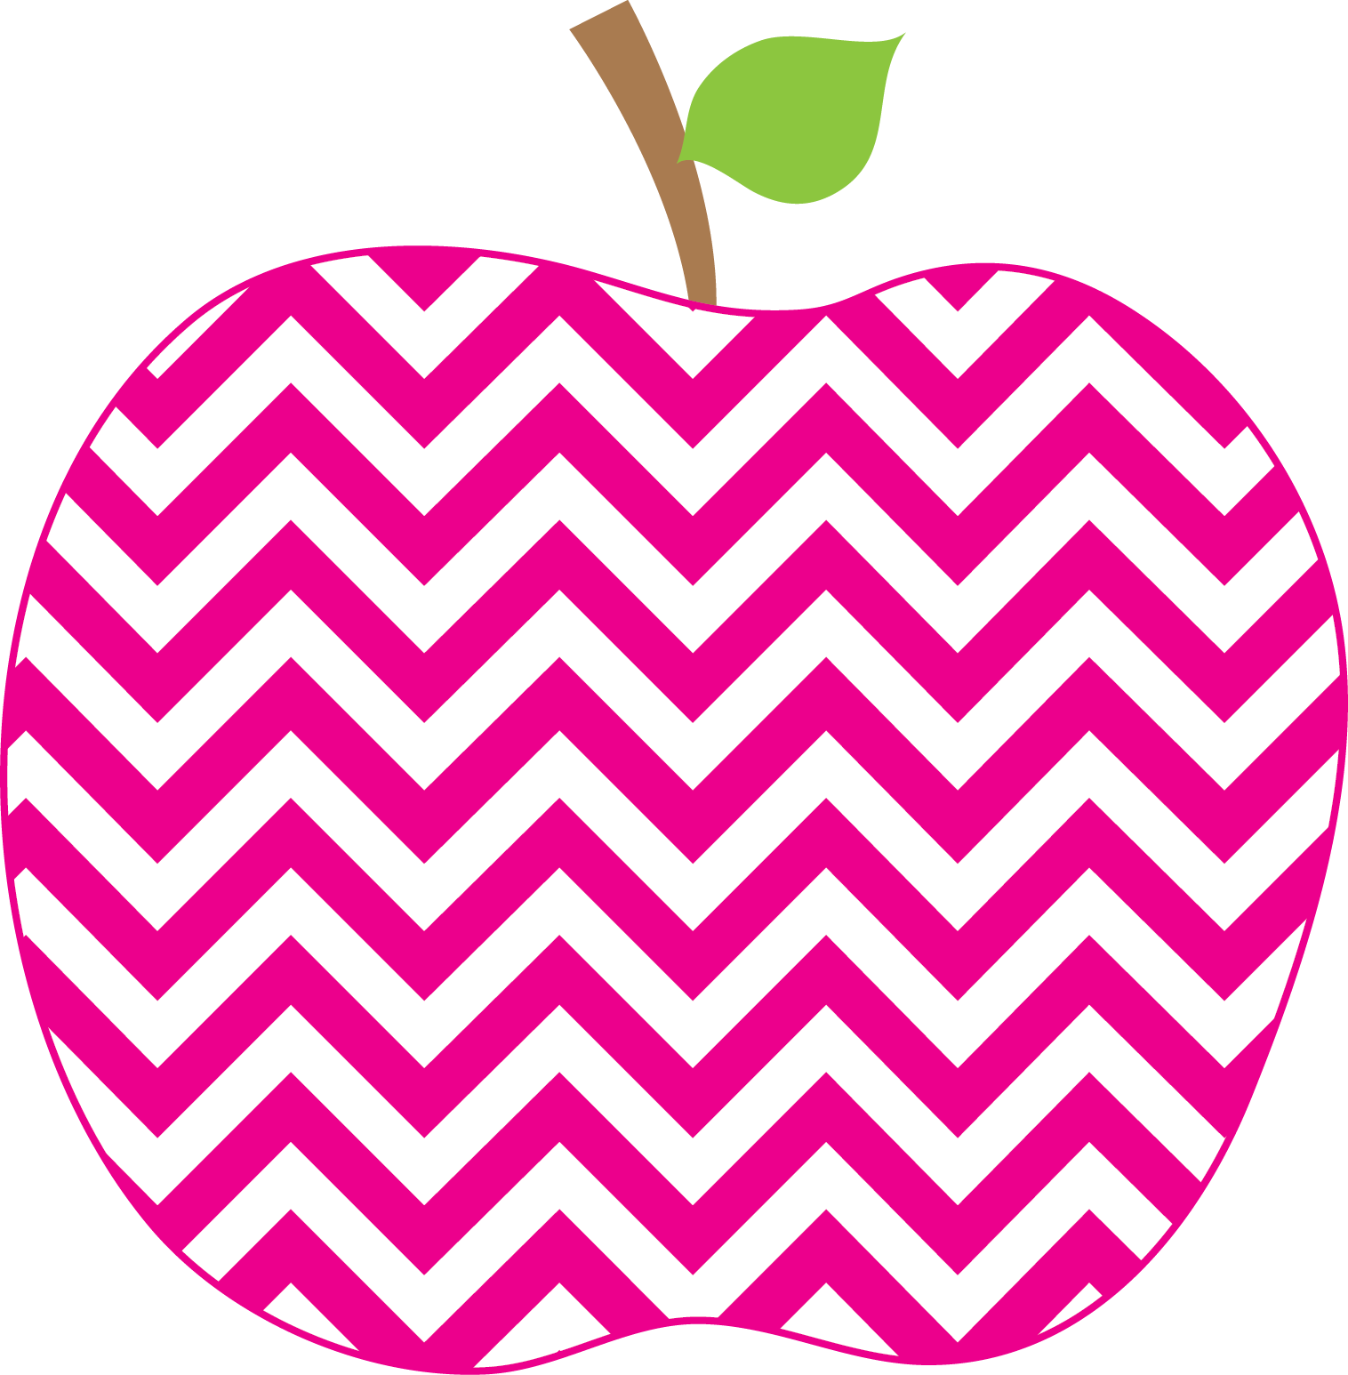

Happy New Year!

Our class wrote new years resolutions. We are going to put them in the hallway for everyone to see!

Reminder: Field Trip on 1/24

Please let me know if you would like to volunteer and you are a WCPSS approved

volunteer for this year!

**REMINDERs:**

* **Send snack daily**
* **Put any transportation change in writing.**

Check out the **challenge activities** on our website to help expand your child’s thinking!

<http://waltzersfirstgraders.weebly.com/challenge-activities.html>

Waltzer Weekly

The

January 3, 2020

**What are we up to in the curriculum? (This is an overview. Watch out for our weekly email to give you more insight.)**

**Letterland:** Students can read and write with vowel patterns and word families. Letterland unit dates are in your child’s homework folder with the word lists. **New suggestions for practicing are now in the homework folders too!**

**Reading:** Students are reading non-fiction text then identifying the main idea and details. Students can also identify and describe the purpose of non-fiction text features such as a glossary, index, table of contents, photos, and labeling.

**Math:** Students can add 3 whole numbers together.

**Writing:** We are completing our how to unit.

**Social Studies:** Students are learning goods and services.