Snow Day Fun Activities!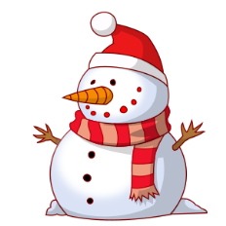
Take a piece of snow or a chunk of ice from outside. Place in a cup. Take an ice cube from your freezer and place in another cup. Write down the time. Make a prediction which one will melt first and why. Write down the time of when each one melted and what your conclusion is. | Write an imaginary story about a snowman coming to life. Does your snowman have friends? What does it do? Use creative details! | Write an all about describing all the winter activities to do outside on a snowy day.  -OR-  Write about fun things to do if you are stuck inside on a winter day.
Write a persuasive letter explaining why winter is or is not a fun time of the year. Give 3 clear and good reasons. Don’t forget your opening sentence and closing sentence! | Write a make believe story where the setting is in winter. Draw a very detailed illustration to go with it. Remember to have a beginning, middle, and end! | Pretend you are interviewing a polar bear or penguin about living in the winter climate year round. List 5-10 questions you would ask your choice. Be creative!

