July/August Challenge Activities
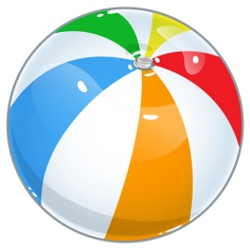
Read a non-fiction book. Share two facts that you have learned. | Read a book. Draw three pictures about it. One for the beginning, one for the middle, and one for the end. Use your pictures to retell the story to someone. | Writing Activity: If you were a super hero, what super power would you want to have? Why?
List ten describing words about summer. | Have someone time you as you count to 120 as fast as you can. | Visit a place in your community. It could be a store, restaurant, school, or even a fire station. Write about why it is important to you.
Read a fiction book. Draw a picture of the setting and write 2 describing sentences about it. | How many different number sentences can you make where the answer equals twelve? | Choose a feeling like happy, sad, angry, or excited. Write a personal narrative describing the events that made you feel that way.
Interview a family member. Write down 5 questions you have. What did you learn after asking those questions? | Help a family member write out a grocery list. How is this list helpful? | Read a book of your choice. Write a letter to the author explaining why you liked the book. Give one example from the book of what you liked and why.

